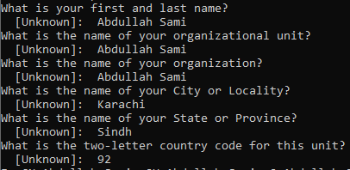

MYAPP_UPLOAD_STORE_PASSWORD=12345678

MYAPP_UPLOAD_KEY_PASSWORD=12345678